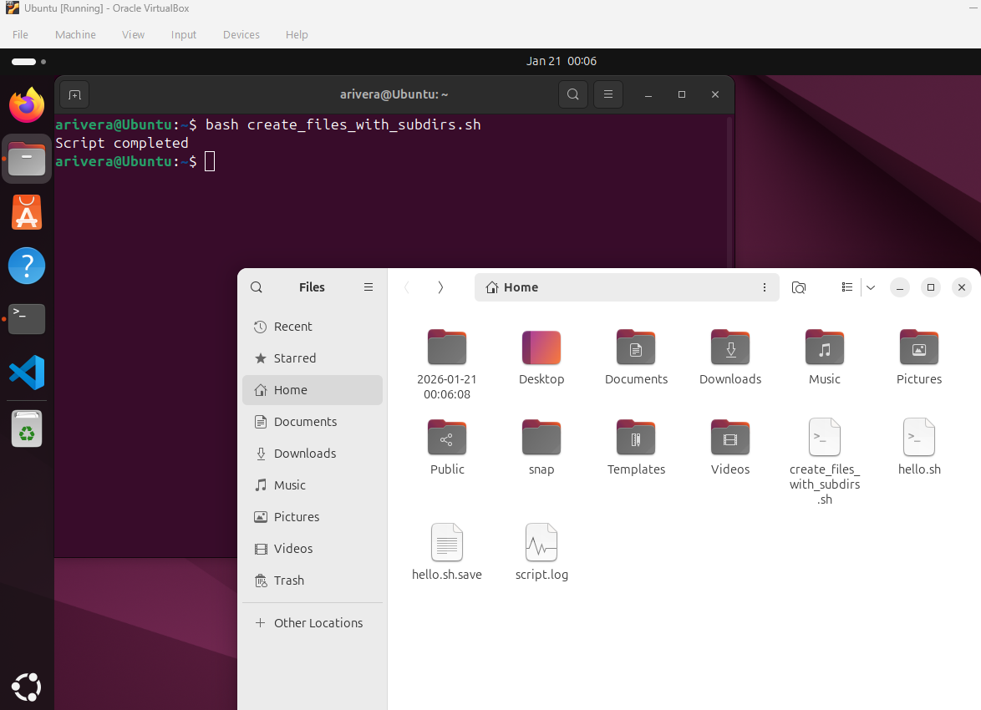

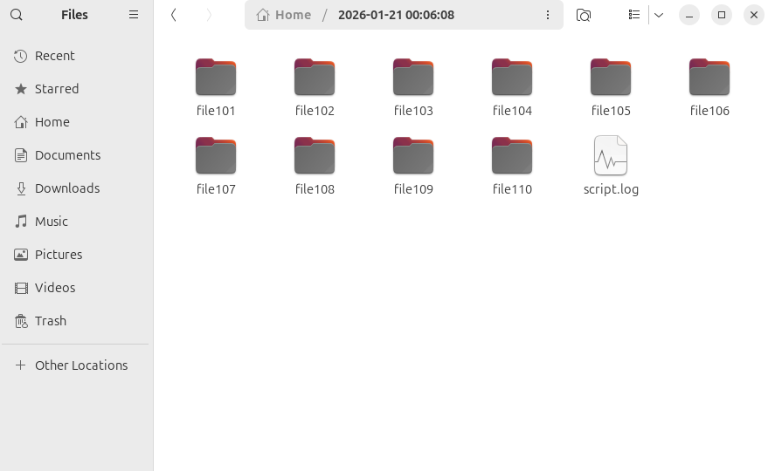

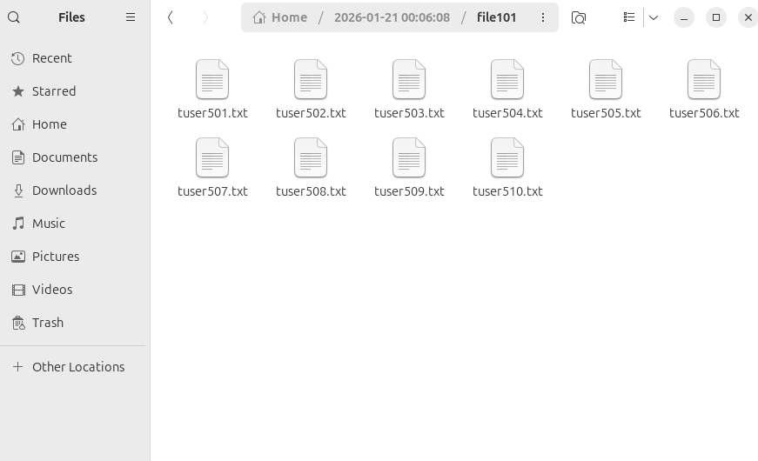

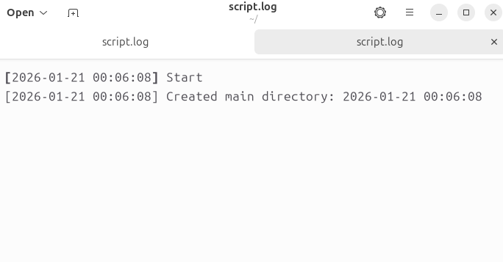
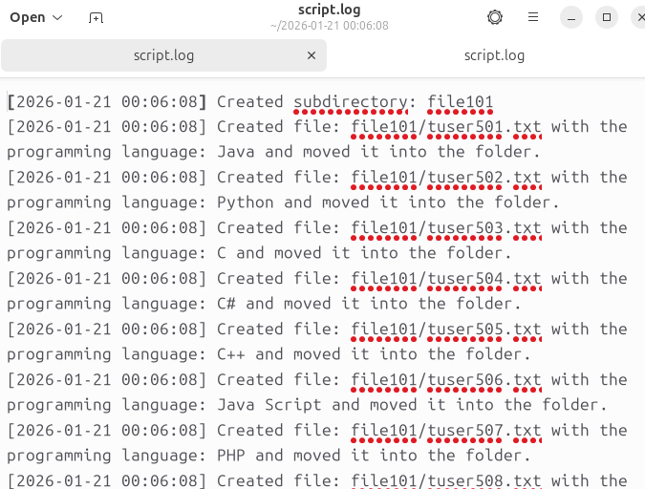

“cp”: stands for “copy”. It allows files and directories to be copied from one location in the system to another. In the terminal it looks like:
cp [option] …SOURCE…DESTINATION
After this command is run the file(s) that you are copying are then sent as a copy to the destination.

“ps” : stands for “process status”. This command displays the current running processes of the system, such as memory usage, and CPU time. In the terminal it looks like:
ps, ps -e, ps ax, ps -ef, ps aux (each is dependent on the format you want to use)
After this command is run the terminal will show the running processes information.

“ls”: stands for “list of contents”, which includes the content of a directory such as files and subdirectories. Without an option paired with it it displays the names of all the files and directories in the current directory you are in, in alphabetical order. In the terminal it looks like:
ls
After this is inputted a list of files and directories will be shown that are within the current directory.

“mv”: stands for “move”. This moves files and directories from one location to another while also allowing the file to be renamed. In the terminal it looks like:
mv [OPTION]…SOURCE…DESTINATION
mv old_name.txt new_name.txt
After the command is used you can move files from one location to another and or rename a file or directory.

“rm”: stands for “remove”. This command is used to permanently delete files, directories and links from a system. In the terminal it looks like:
rm filename.txt
After the command is run the specified file, link, or directory is deleted.

“mkdir”: stands for “make directory”. This command creates new directories within the current directory you are in, unless you specify a specific path. In the terminal it looks like:
Mkdir new_directory
After the command is run a new directory is then created within the current working one.

“rmdir”: stands for “remove directory”. This command is used to remove empty directories from the system. In the terminal it looks like:
rmdir dirname
After the command is run the selected directory is then removed.

“pwd”: stands for “print working directory”. This command is used for displaying the full path of the directory you are currently working in within the system. In the terminal it looks like”
pwd
After it is run the current directory is show such as /home/user/ Documents.

“stat”: stands for “status”. This command displays detailed metadata and status information about a specific file or system. In the terminal it looks like:
stat file.txt
After this is run the metadata for the file is then displayed for the user to see.

“tar”: stands for “Tape Archive”. This command is a utility that is used to bundle multiple files and directories into a single archive file. In the terminal this looks like:
Tar -czvf archive.tar.gz
After this is run the files are then archived together in a single file.

“apt”: stands for “advanced package tool”. This command manages the software packages that are installed on the system, and only the root user can use this command. In the terminal it looks like:
apt update
After this command is run the system will install any updates needed.

“echo”: this command displays a line of text or string arguments to the terminal screen. In the terminal it looks like:
echo “Hello, World!”
After this command is run it will print out the string “Hello, World!” to the terminal.

“cat”: Stands for “Concatenate”. This command is used to display file contents, combine multiple files into one and create new files by reading user inputs. In the terminal it looks like:
cat filename.txt
After the command is run the file contents will be shown to the user.

“more”: This command is a utility used for viewing contents of a text file one page at a time. Usually useful with larger files or log outputs. In the terminal it looks like:
more myfile.txt
After this command is run it will display the contents one page at a time.

“less”: Fundamentally this command works the same as more but allows for forward and backward navigation. In the terminal it looks like:
less [options] [filename]
After the command is run the contents, just like more, will be shown one page at a time, but also allow for forward and backward navigation in the file.

“date”: This command is used to display the current date and time of the system as well as set the system clock as well as calculations for date and time.in the terminal it looks like:
date
After the command is run it will display the current system’s date and time.

“time”: This command is used to measure the execution duration, and resource usage of another command or script. In the terminal it looks like:
time <command>
After the command is run it will show the user the execution time of the command used.

“kill”: This command is used to send a signal to a process or group of processes allowing you to terminate them. In the terminal it looks like:
kill [options] <process_id>
After the command is run the specified process is terminated.

“history”: This command is usually used by bash, it records a numbered list of commands previously typed in the terminal allowing you to recall, reuse or edit and search for them to help save time. In the terminal it looks like:
History [num]
After this command is run, a list of a specified integer amount will show the last num of commands used

“chmod”: stands for “change mode”. This command is used to modify the read, write, and execute permissions of a file and directories. As well as who can access a file and what they can do with it. In the terminal it looks like:
Chmod +x filename
After the command is run, the specified file will then have execution permission.

“chown”: This command is used to change the owner and/or the group of a specified file or directory. In the terminal it looks like:
Chown user1 filename.txt
After this command is ran the owner of the file is changed to user1, but the group ownership is not changed.

My script creates a main directory that is named by the date and time of creation and creates a log file of when the directory is created and when the script was started. After creation, the subdirectories are then created as well as the txt files with a different programming language written in each file, up to a maximum of ten files and subdirectories. The txt files are then put into each subdirectory, and a log file is created that documents when each subdirectory and text file was created as well as what programming language is written in each txt file. The purpose of the script is to practice creating a main and subdirectory as well as show when everything starts, is created, and finished.

